IOT Liquid Level Monitoring System

This project IOT Liquid Level Monitoring system is a very innovative system which will inform the users about the level of liquid and will prevent it from overflowing. To demonstrate this the system makes use of 4 containers. For this the system uses ultrasonic sensors placed over the containers to detect the liquid level and compare it with the container’s depth. The system makes use of AVR family microcontroller, LCD screen, Wi-Fi modem for sending data and a buzzer. The system is powered by a 12V transformer.

The LCD screen is used to display the status of the level of liquid in the containers. Whereas a web page is built to show the status to the user monitoring it. The web page gives a graphical view of the containers and highlights the liquid level in color in order to show the level of liquid. The LCD screen shows the status of the liquid level. The system puts on the buzzer when the level of liquid collected crosses the set limit. Thus this system helps to prevent the wastage of water by informing about the liquid levels of the containers by providing graphical image of the containers via a web page.

Block Diagram:

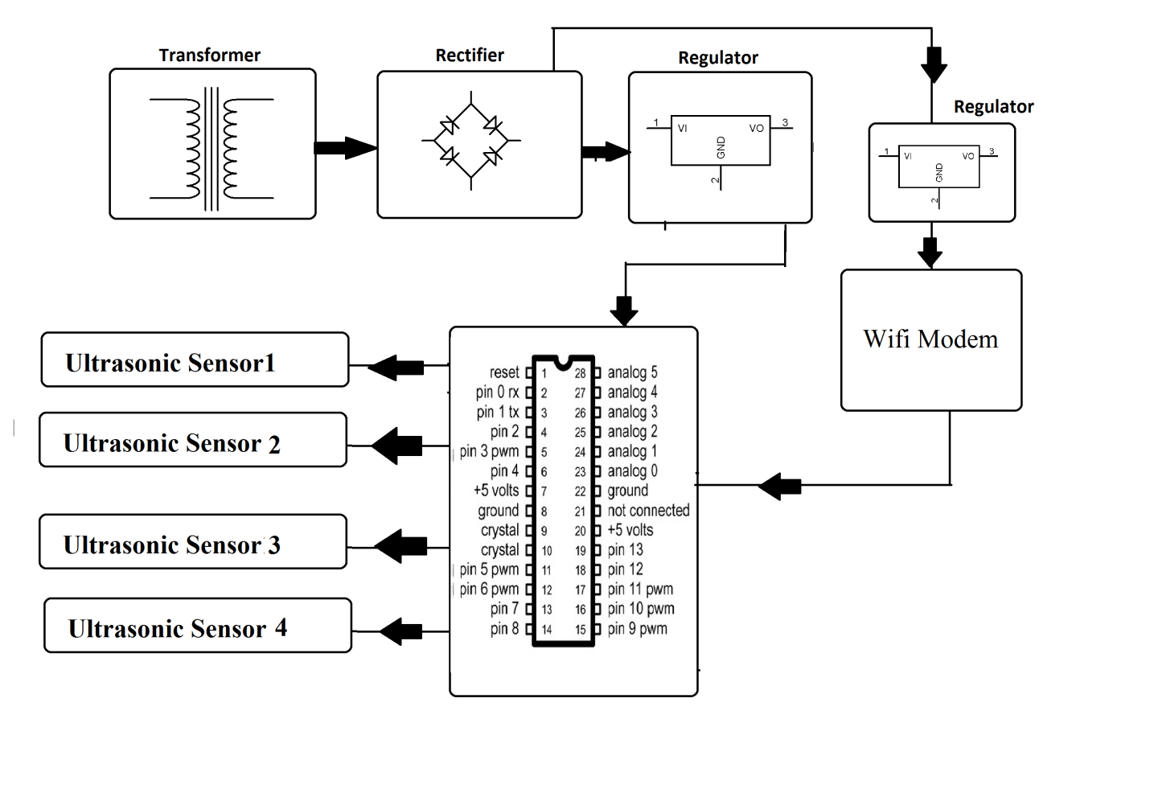

Hardware Specifications
- AVR family microcontroller
- Wi-Fi Modem
- LED’s
- LCD Display
- 12V transformer
- Ultrasonic sensors
- Resistors
- Capacitors
- Diodes

Software Specifications
- Arduino Compiler
- MC Programming Language: Embedded C
- IOTGecko

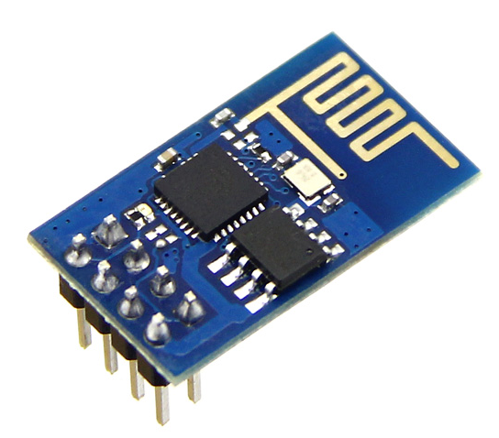
WIFI Modem:
- The ESP8266 Wi-Fi Module is a self-contained SOC with integrated TCP/IP protocol stack that can give any microcontroller access to your Wi-Fi network. The ESP8266 is capable of either hosting an application or offloading all Wi-Fi networking functions from another application processor. Each ESP8266 module comes pre-programmed with an AT command set firmware. The ESP8266 module is an extremely cost effective board with a huge, and ever growing, community.
- This module has a powerful enough on-board processing and storage capability that allows it to be integrated with the sensors and other application specific devices through its GPIOs with minimal development up-front and minimal loading during runtime. Its high degree of on-chip integration allows for minimal external circuitry, including the front-end module, is designed to occupy minimal PCB area. The ESP8266 supports APSD for VoIP applications and Bluetooth co-existence interfaces, it contains a self-calibrated RF allowing it to work under all operating conditions, and requires no external RF parts.
- There is an almost limitless fountain of information available for the ESP8266, all of which has been provided by amazing community support. In the Documents section below you will find many resources to aid you in using the ESP8266, even instructions on how to transforming this module into an IOT (Internet of Things) solution!
- Note: The ESP8266 Module is not capable of 5-3V logic shifting and will require an external Logic Level Converter. Please do not power it directly from your 5V dev board.

Features:
- 802.11 b/g/n
- Wi-Fi Direct (P2P), soft-AP
- Integrated TCP/IP protocol stack
- Integrated TR switch, balun, LNA, power amplifier and matching network
- Integrated PLLs, regulators, DCXO and power management units
- +19.5dBm output power in 802.11b mode
- Power down leakage current of <10uA
- 1MB Flash Memory
- Integrated low power 32-bit CPU could be used as application processor
- SDIO 1.1 / 2.0, SPI, UART
- STBC, 1×1 MIMO, 2×1 MIMO
- A-MPDU & A-MSDU aggregation & 0.4ms guard interval
- Wake up and transmit packets in < 2ms
- Standby power consumption of < 1.0mW (DTIM3)
Reference
- http://ieeexplore.ieee.org/xpl/articleDetails.jsp?arnumber=5620816&queryText=liquid%20level%20ultrasonic&newsearch=true

